From Photo dot net site
The Agfa Rapid system was an odd compromise between 126 cartridge film and standard 35mm cassettes. Many manufacturers created quite sophisticated cameras for what was basically a point-and-shoot concept, and I recently acquired a couple of rather nice examples.
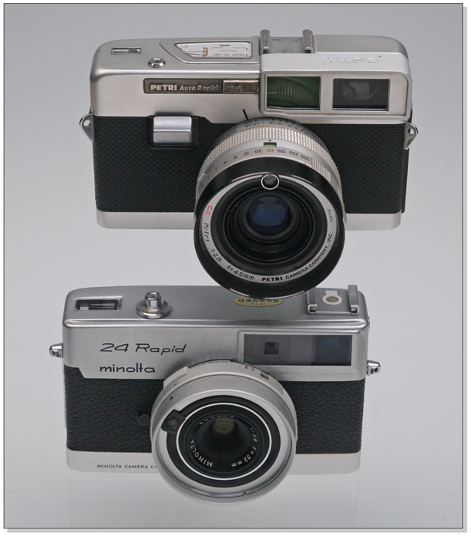
Petri Auto-Rapid 2.8 & Minolta 24 Rapid

Responses

The top camera is a Petri Auto-Rapid 2.8, and the lower one is a Minolta 24 Rapid, both from the '60's. Both are well-made little rangefinder cameras and both use the extinct PX625 mercury cell for metering; the Minolta offers shutter-preferred automatic exposure with full manual metered over-ride, and the Petri uses a center-the-needle system, visible in the viewfinder. The Petri has a full range of shutter speeds from "B" through 1/500, while the Minolta has a limited range consisting of "B", 30, 60, 125 and 250. The much rarer Petri is unusual in that it produces images in the standard 35mm format, and consequently has a 45mm lens, while the Minolta shoots in the more typical Rapid 24x24mm square format, and has a 32mm lens. I like the understated styling of the Minolta better than that of the slightly flashier Petri, which resembles a scaled-down version of the sought-after Petri Racer, so the rest of this post will be devoted to the Minolta 24 Rapid, and I may do something with the Petri at a later date.
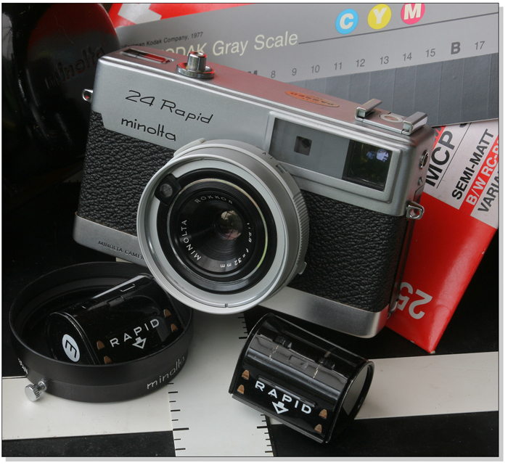
Minolta 24 Rapid

The Agfa Rapid system appeared in 1964, as a competitor to Kodak's 126 cartridge-load system. It was a successor to Agfa's pre-war Karat configuration, with the film unwinding from one cassette to be fed into another, with no spindle inside the cassettes, the film just curling itself into a roll with the aid of a sprung guide within the container. There was therefore no need to rewind the film, the now-filled container being removed and replaced with the empty one from the other side of the camera. Loading is quick and simple, with the film leader being fed across the sprocket drive and film gate and inserted into the empty container, the film travelling from right to left instead of the conventional left to right. Shut the back, fire off a couple of blanks, and you're in business.
While one advantage was the fact that, if the camera back was accidentally opened, only the strip of film exposed across the gate would be fogged, and certainly the loading procedure was relatively quick and easy, numerous disadvantages plagued the system. Because the film has to be pushed by the sprocket drive across the film gate and into the take-up container, a fair amount of pressure is involved, which increases as the container fills, so the amount of film was limited to short lengths, about the same as in a 12-shot 35 mm cassette. This give 18 frames in the square format, or 12 in the regular format employed by the Petri, a severe disadvantage unless one enjoys forever loading and unloading film. If the film was reluctant to coil smoothly in the take-up container, resulting in increased pressure, there was a tendency for the sprocket holes to rip, an irrecoverable situation unless some serious darkness was readily available. I've been reloading the Rapid cassettes in the darkroom for use in these cameras, and have encountered this problem more than once. Here's a pic of the system with the film happily in place.
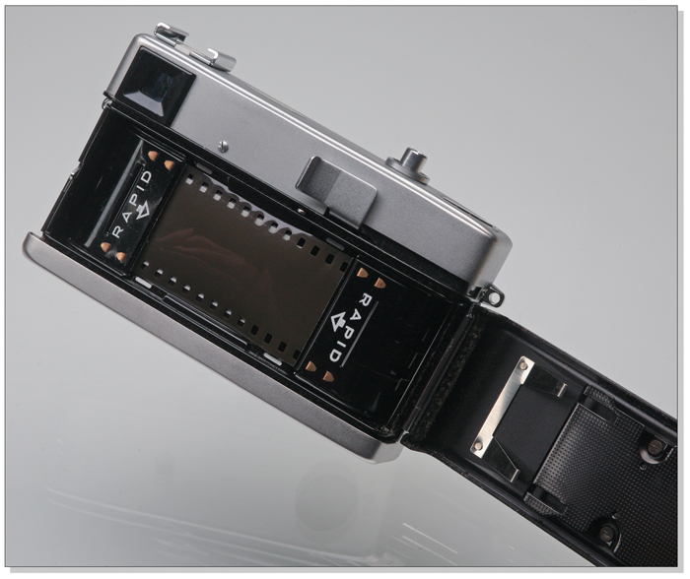
Film Loaded

And here's a pic showing most of the components:
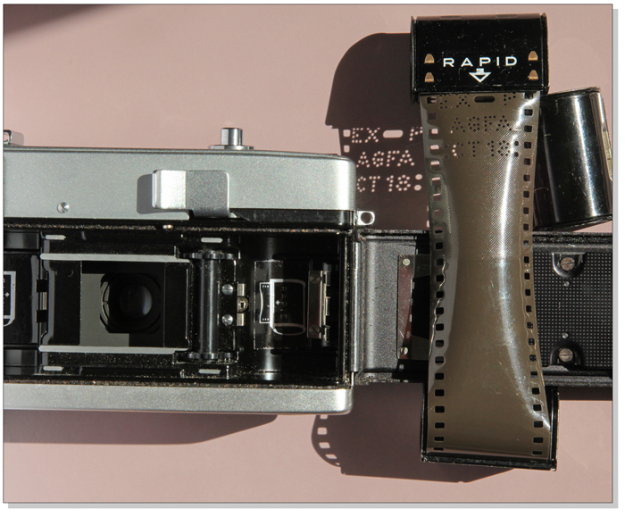
Rapid components
Great pair of cameras. I've seen ads for the Minolta, but somehow missed seeing the Petri. Besides the full frame Petri and 24x24 Minolta, I believe that some rapid loaders used the half-frame (18 x 24) format. Thanks for an informative post.
Too bad Kodak didn't adopt this system instead of the 126 cartridge. We'd still be able to use our old Instamatics today with easy reloading.

You'll observe the sprocket drive in the traditional place, set to push, not pull. Beside it, in the film compartment, is a small metal bar which "reads" the ISO ratingof the film from metal tabs on the film container for setting the exposure metering, various arrangements of the tabs denoting readings of 25, 50, 100 and 200 ISO, I believe, though I have no idea just which were which. The only way to know what film you were using, given the unmarked containers, was by the perforations in the film leader and tail, telling you also if the film was used or unexposed. I'm not sure what one did if the exposed film was inadvertently pushed completely into the container, and I can think of all sorts of opportunities for confusion to arise with these unmarked cans... While quite popular in Europe, the system never really took the world by storm and 126, with all it's shortcomings, went on to dominate the market.
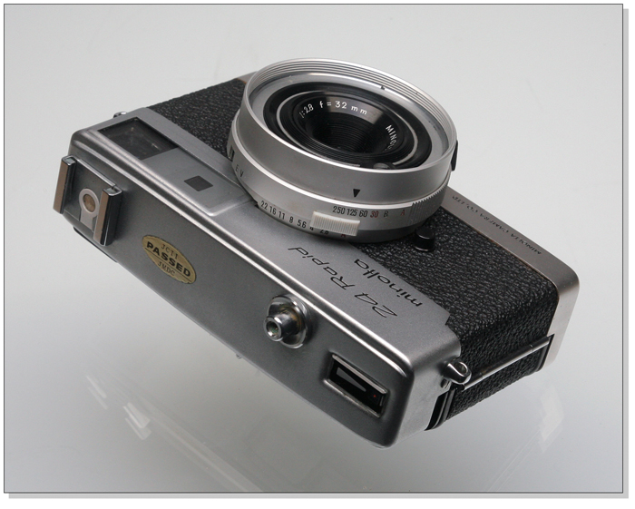
Minolta Top
Rick Drawbridge , Jan 18, 2014; 08:49 p.m.
The Minolta is a very small rangefinder camera with a Seiko shutter and an extremely fine little 32mmRokkor f/2.8 lens. The meter shows enthusiasm when powered up with an EPX625 cell, but as there's no way of manually setting the ISO rating, I relied on manual exposures and Sunny 16 for the pics below. It's a delightful little camera to handle, with contrasty split-image focusing, a bright viewfinder displaying selected apertures, and a gentle shutter release. I loaded a length of Fuji Superia 200 into a Rapid cassette for the colour shots and some Arista 200 for the B&W's, laboriously inching the film into the containers with cotton-gloved fingers. Still, it was worth the effort, the results from the Minolta impressing me greatly. B&W developed in PMK Pyro, all scans from an Epson V700.

